

**Computer Vision Project Group - 7**

**Week-7: Progress Report**

**Project Title:**

**American Sign Language Alphabet Detection**

**Submitted to faculty: Prof. Mehul Raval**

**Group Members:**

| **JILL SHAH** | **AU2040234** |
| --- | --- |
| **KHUSHEE VAKIL** | **AU2040242** |
| **DHRUVI SHAH** | **AU2040263** |

**WORK DONE SO FAR:**

In this week we have worked further on our coding part. We have already classified our data in training and validation sets in a ratio of 80:20 and labeled the different classes. There are 26 classes from a to z and one more class of unknown.

Next, we are building our model using ResNet152 architecture. We are using the same weights as used on the “ImageNet”. We are preprocessing the data here.

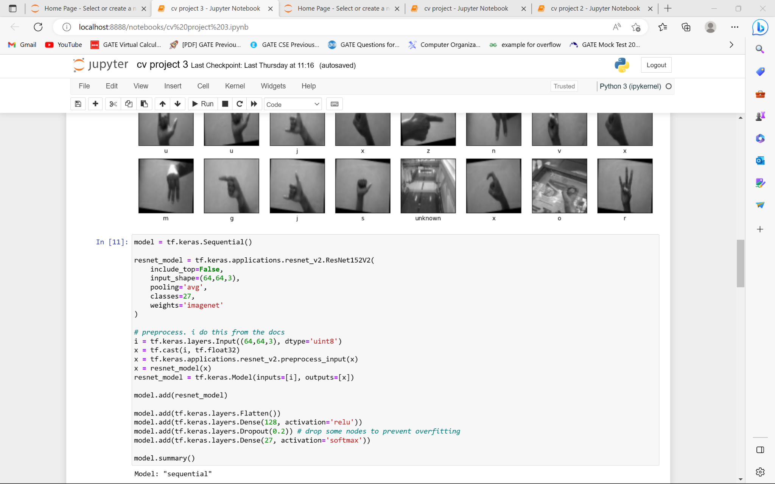



The model summary shows the total number of parameters and the trainable and non-trainable parameters from the total parameters.

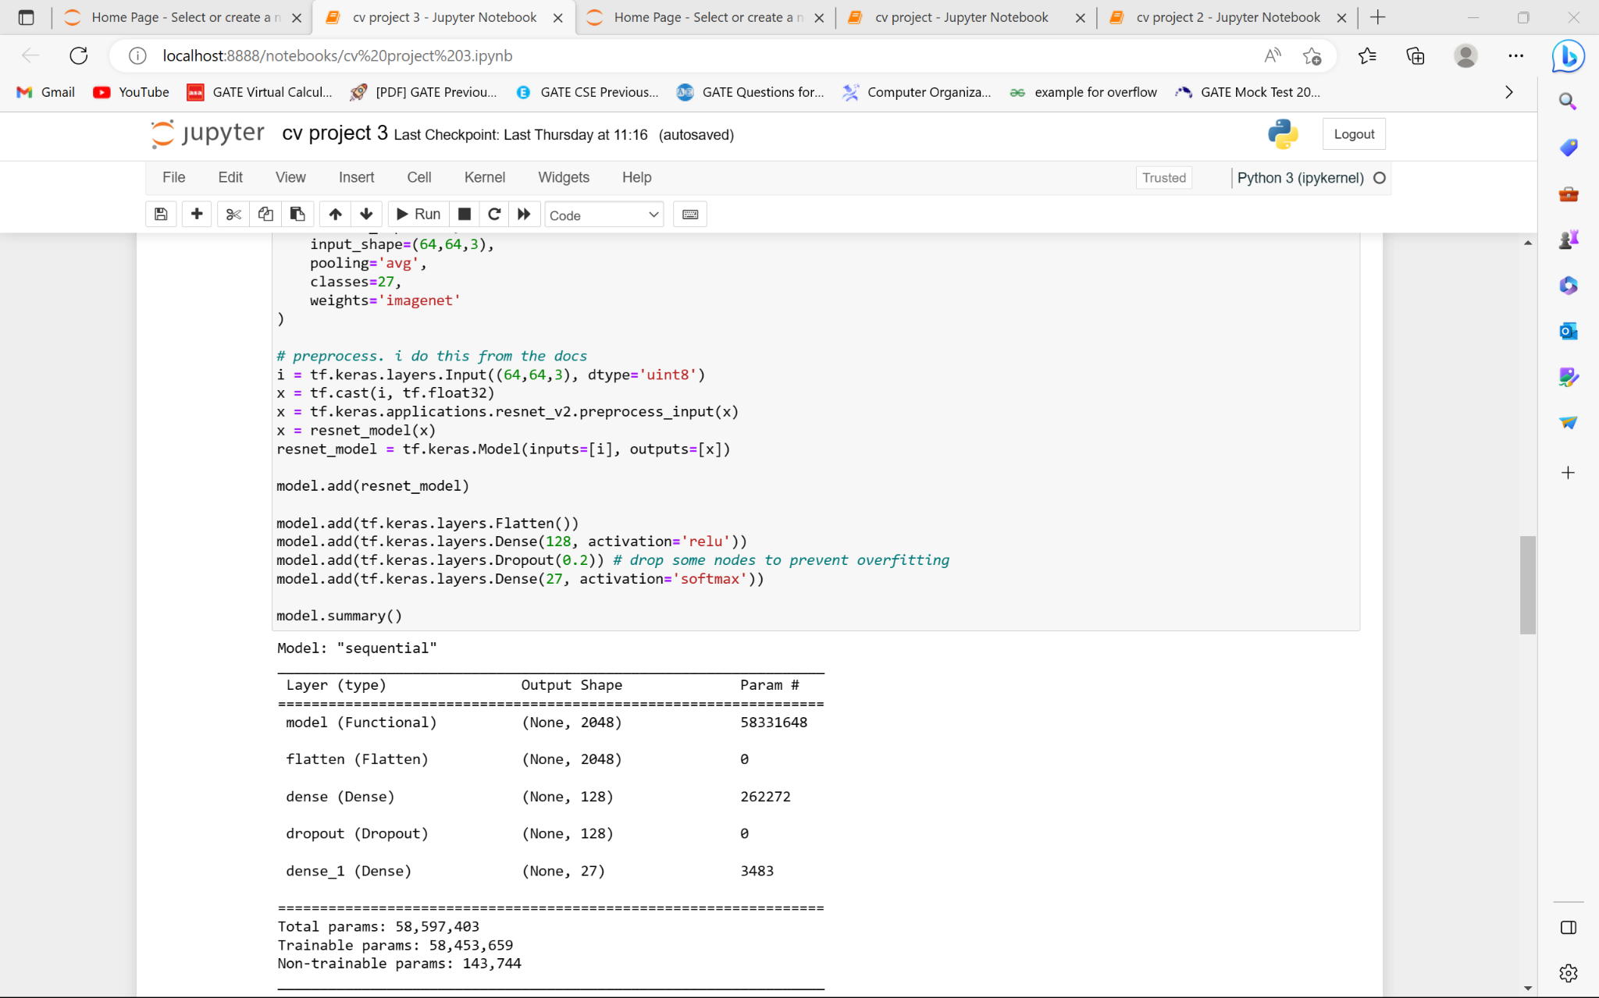

We have used the “Adam” optimizer and we are calculating the loss function using the “sparse categorical cross entropy”.

We now use the training data to train the model. For training purposes, we’ve adopted the typical validation split of 0.2. There are 15 epochs.

The model training process can take several minutes.

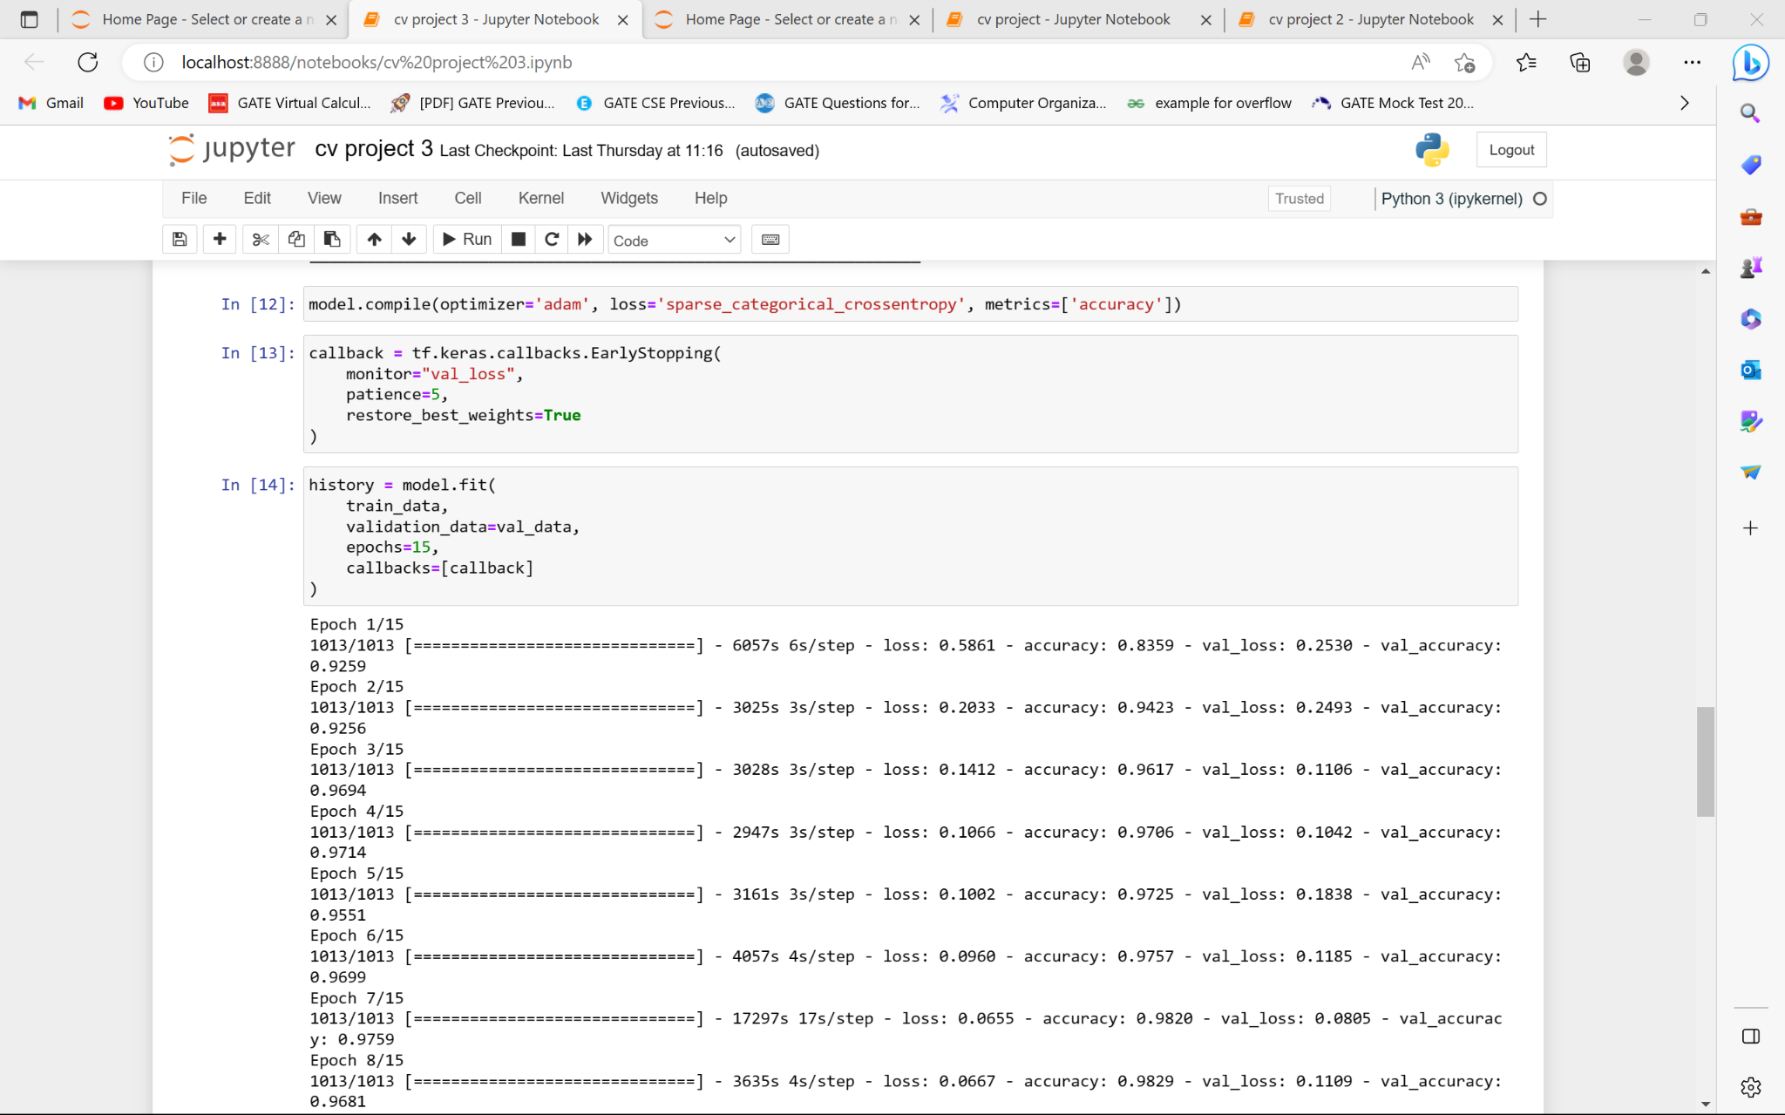

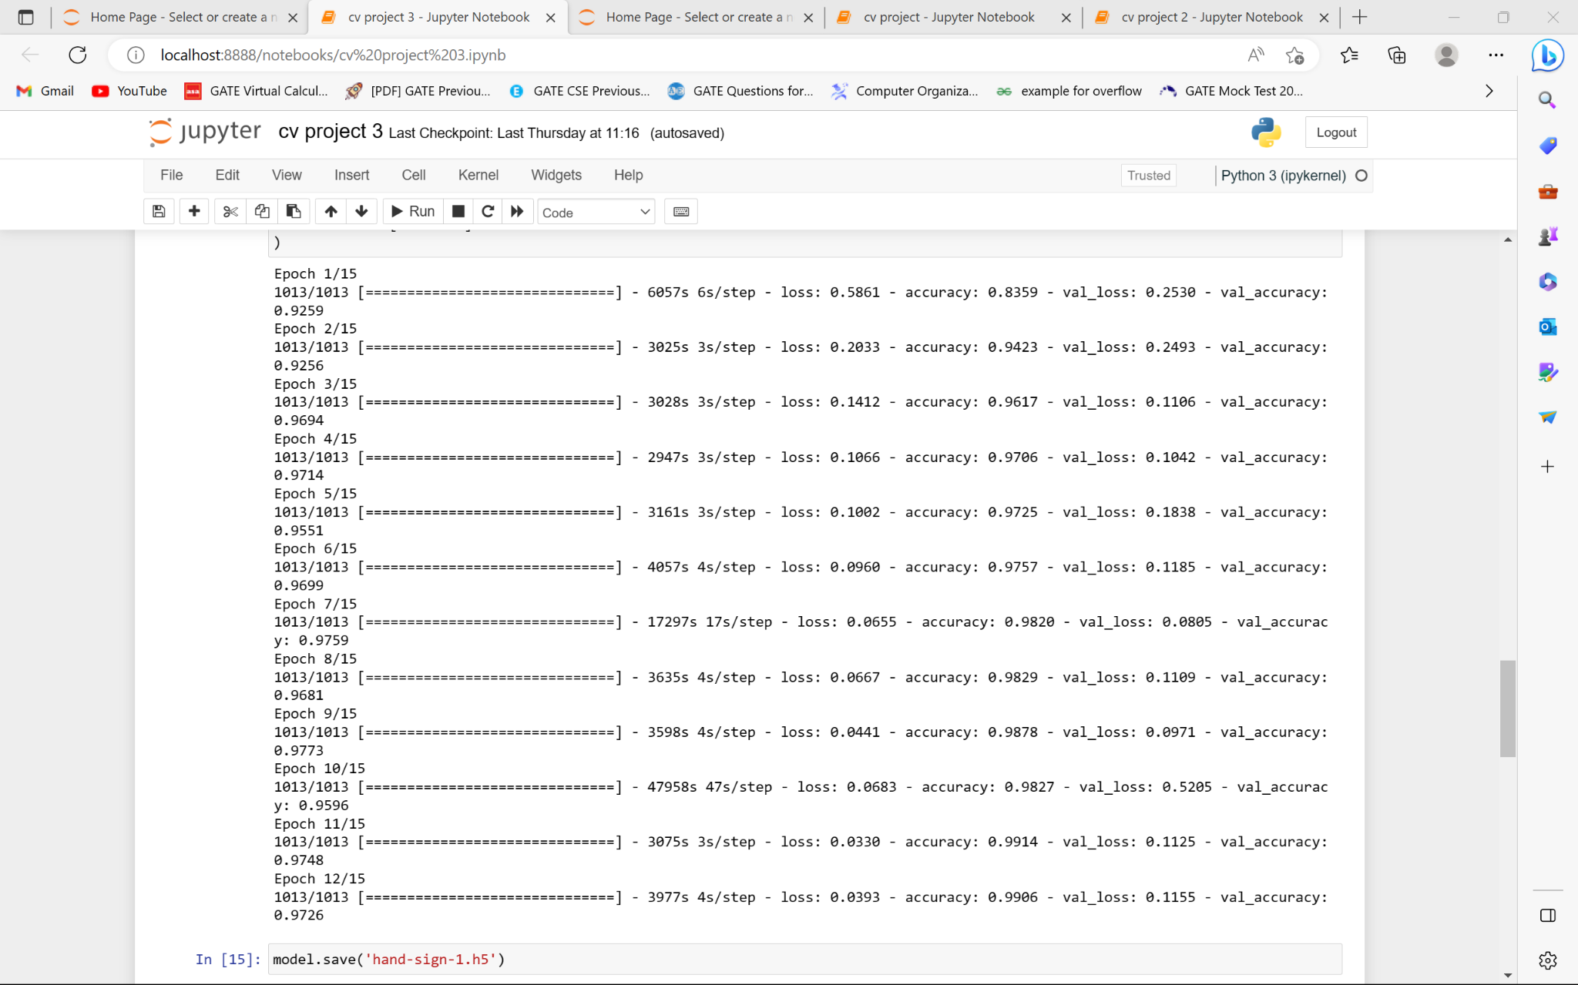

After saving, we evaluate the model. This model has an accuracy of 0.9759 and a loss of 0.0805. (sparse categorical cross-entropy). Because the EarlyStopping function stops training and uses the best weights—weights from epoch 15—the weights used in this model are from that epoch.

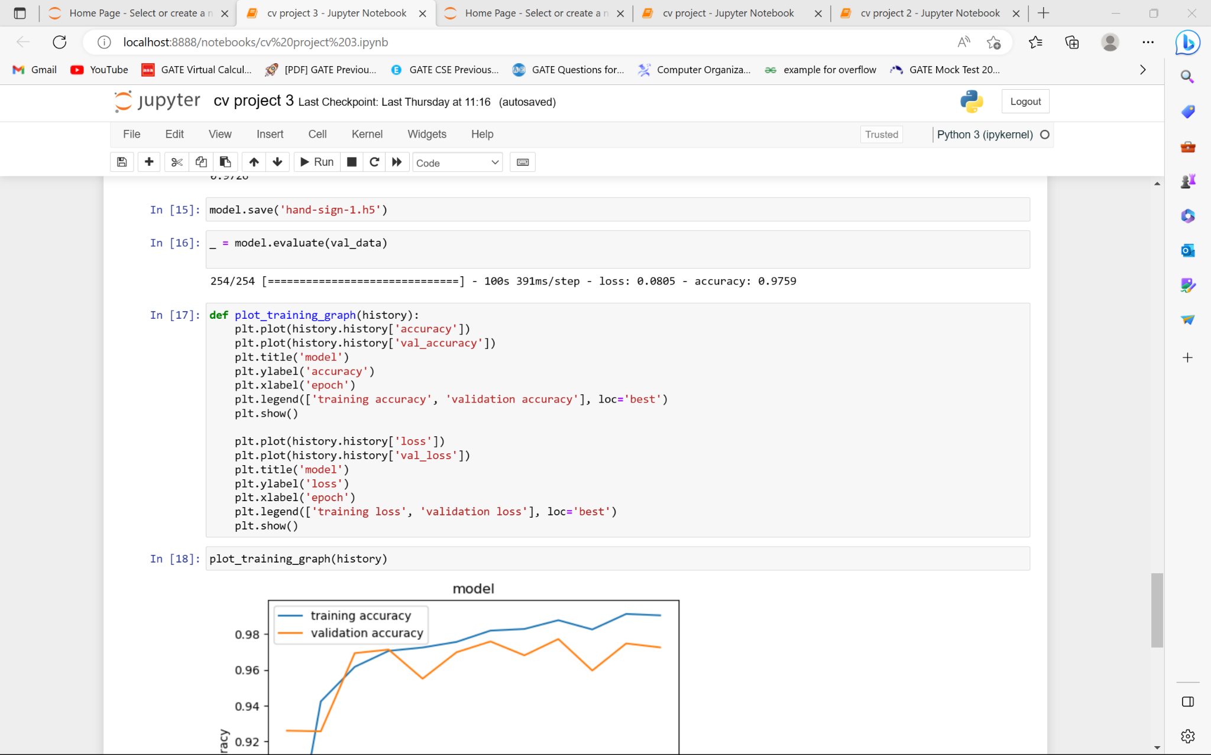

Next, we plot the model's training accuracy and validation accuracy and the loss suffered by the model.



From the graphs, we can see that the accuracy of the training model and validation model are quite high but in our graph of model vs loss, we can see that there is a sudden jump in the validation loss around 8-10 epochs.

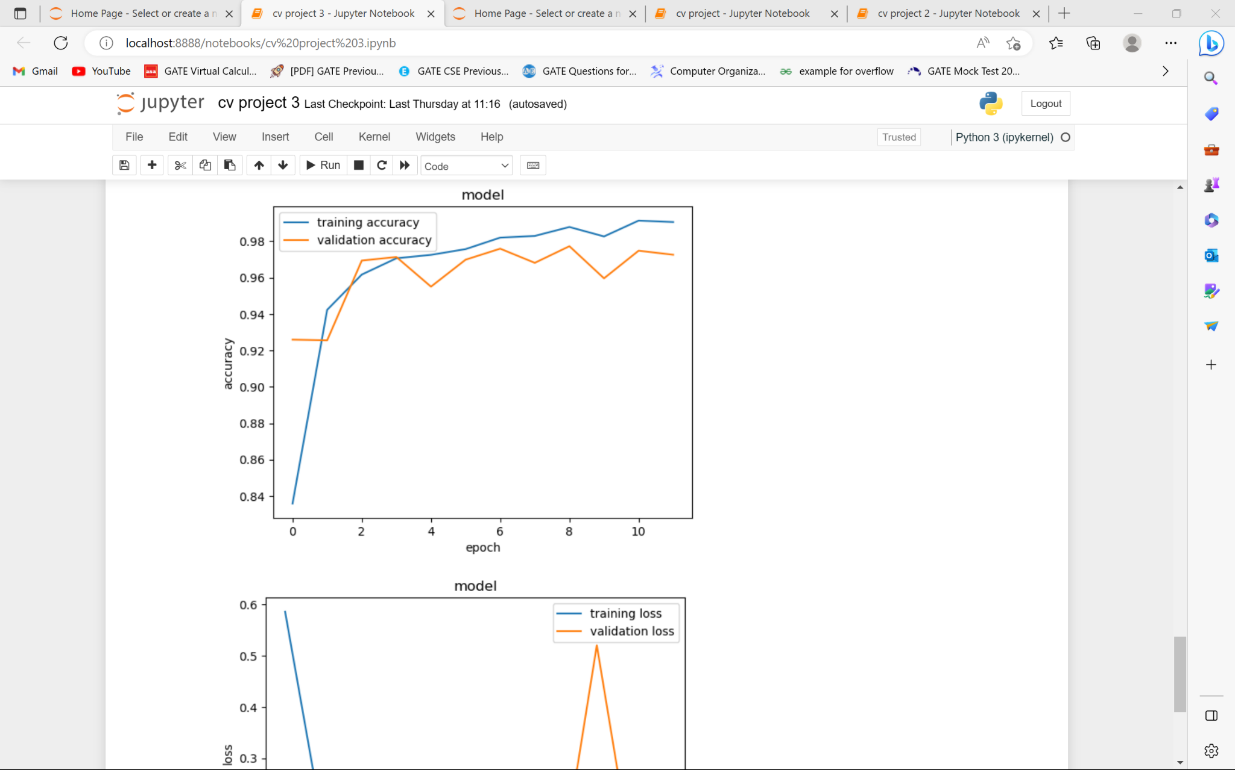

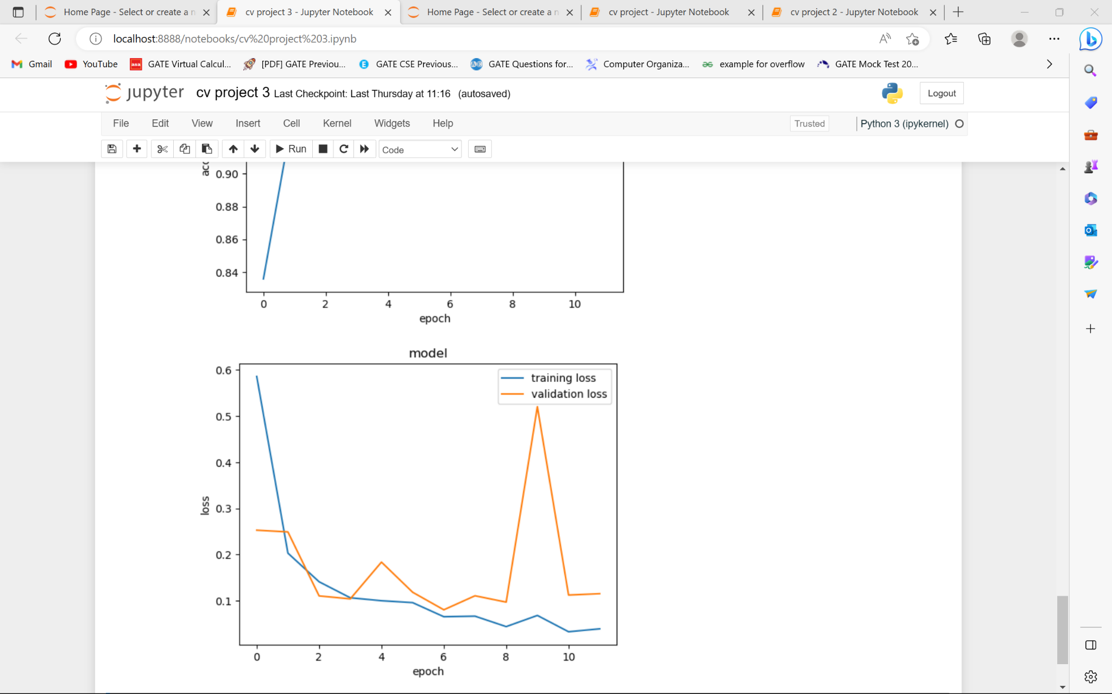

**WORK FOR THE NEXT WEEK:**

To try to avoid the sudden increase in validation data value and test our model.